PowerMic Utilities for Firmware Upgrades

Issue: User reports intermittent problems with their microphone (such as cutting in and out, latency issues, not picking up the first few dictated words, buttons not working properly on the mic, etc.), a firmware update should be attempted.

Directions:
- Connect to the user’s workstation and determine if the user has a PowerMic II or a PowerMic III (Note: When the user is on the PS360 login screen, the microphone is listed in the lower right hand corner).

- Close out of PowerScribe.
- Create a folder on the desktop labeled “Mic Tools”.
- Follow steps below for the PowerMic II or PowerMic III:
PowerMic II:  - Send files pm2_update.exe and upgradePM2Firmware.bat to the Mic Tools folder you created on the user’s desktop. PowerMic II files can be found here.  - Open the Mic Tools folder on the user’s workstation and double click to run the upgradePM2Firmware file.  - The following (image below) runs on the workstation. “FW update successful” when the firmware is updated. When it finishes running, press any key to close the window.  - Delete the Mic Tools folder from the user’s desktop.  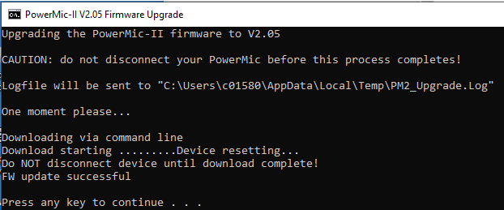 | PowerMic III:  - Send file PM3_update_v105.exe to the Mic Tools folder you created on the user’s desktop. PowerMic III files can be found here.  - Open the Mic Tools folder on the user’s workstation and double click to run the upgradePM2Firmware file.  - When it finishes running, press any key to close the window.  - Delete the Mic Tools folder from the user’s desktop.

